PINPOINTING MESSIAH’S NATIVITY—MICAH’S PROPHECY
By Charles E. McCracken
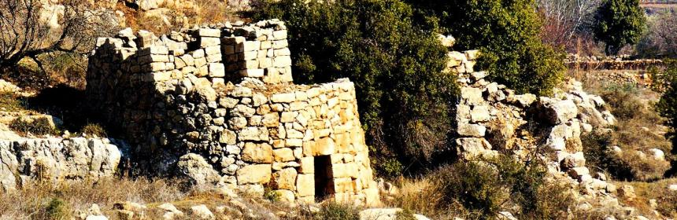

The temple shepherds who first heard the announcement of the Savior’s birth would have been aware of Micah’s prophecy. Not only confirmation of Messiah’s connection to the Davidic Covenant, the prophet Micah also names the location of Messiah’s birth in the environs of Bethlehem.
After hearing the Good News, the shepherds determined:
“Let’s go to Bethlehem and see this thing that has happened, which the Lord has told us about” (Lk. 2:15).
How did they know where to go?
People of faith well know the Old Testament prophecy that identifies the city of Messiah’s Nativity. Micah’s prophecy was used for every Christmas Eve program throughout my childhood as a recitation or responsive reading.
“But you, Bethlehem Ephrathah, though you are small among the clans of Judah, out of you will come for me one who will be ruler over Israel, whose origins are from of old, from ancient times” (Mic. 5:2).
In the broader context of this particular prophecy, one less familiar pinpoints the precise location of the birthplace of Messiah. Micah predicted,
“And you, O tower of the flock,
The stronghold of the daughter of Zion,
To you shall it come,
Even the former dominion shall come,
The kingdom of the daughter of Jerusalem” (Mic. 4:8).
Although often overlooked, Micah discloses that Messiah who fulfills the Davidic Covenant (the former dominion), “was to be revealed from Migdal Eder; the tower of the flock.” (1) Bible historian Alfred Edersheim suggests Migdal Eder—located on the northern outskirts of Bethlehem—was a watchtower used for the protection of temple flocks.
The precise location is unknown; however, some scholars believe Migdal Eder was a short distance from the main road linking Jerusalem to Bethlehem. Today, it is called the “Old Hebron Road” entering Bethlehem from the northeast.
On the night of the Nativity, the sky burst into blinding light on the fields near Bethlehem. An angel spoke to the shepherds,
“Do not be afraid, for behold, I bring you good tidings of great joy which will be to all people. For there is born to you this day in the city of David a Savior, who is Christ the Lord. And this will be the sign to you: You will find a Babe wrapped in swaddling cloths, lying in a manger.” (Lk. 2:10-12).
While, there is no indication of angelic GPS or even verbal directions to guide the shepherds to the manger, there is also no mention of confusion or frantic discussion concerning an extensive search for the baby.
The narrative candidly asserts, “And they came with haste and found Mary and Joseph, and the Babe lying in a manger” (Lk. 2:16).
The location of the closest manger likely was Migdal Eder at the edge of the fields where these shepherds were watching their sheep—the very place Micah prophesied that Messiah would be revealed!
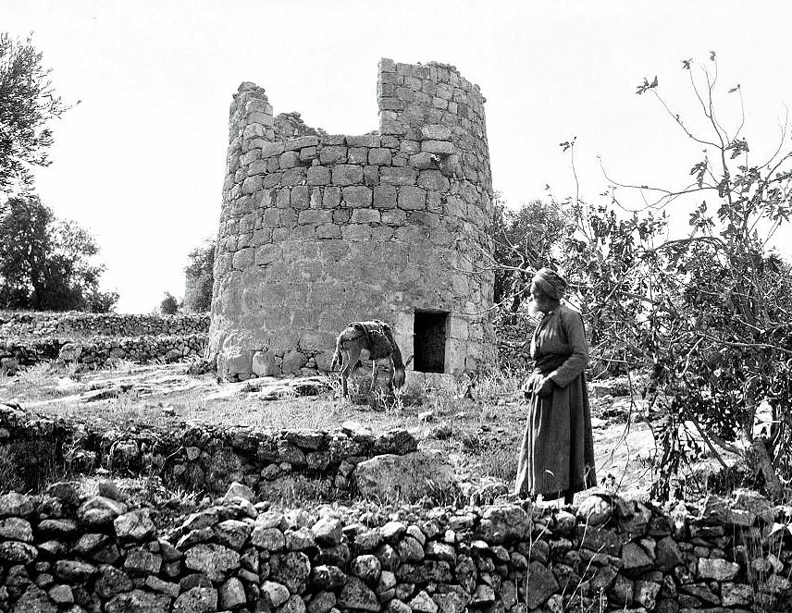
1) Watchtower, Shepherd’s Fields, Bethlehem (circa. 1934). (Image credit: American Colony (Jerusalem), via Library of Congress/[Public domain]/Enhancement, MKM Portfolios)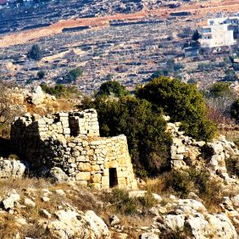
2) Bethlehem Vineyard Watchtower. (Image credit: Wikimedia/[Public domain]/Enhancement, MKM Portfolios)

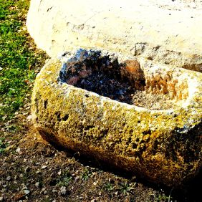
3) Stone Manger at Tekoa, Judea-Samaria. (Image credit: By Todd Bolen/BiblePlaces.com/Author’s collection/Enhancement, MKM Portfolios)

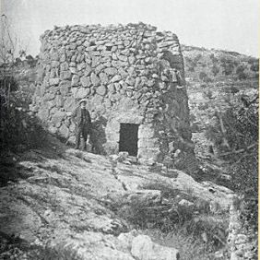
4) Watchtower in the Judean Hills. (Image credit: By Todd Bolen/BiblePlaces.com/Author’s collection/Enhancement, MKM Portfolios)

With the city of Bethlehem crawling with people, guestrooms filled to capacity and Mary’s delivery close at hand, the tower of the flock that she and Joseph passed entering Bethlehem may have been their only hope for shelter and seclusion. It is plausible this was the first place the shepherds would look after receiving the Good News.
The shepherds immediately grasped the implications of the angel’s announcement. They knew Messiah had to be a descendant of King David in fulfillment of the Davidic Covenant. Mary and Joseph’s presence in Bethlehem as a result of the census imposed by Caesar Augustus confirmed His lineage (Lk. 2:4).
The shepherds would have known the sign Isaiah gave to identify the promised Messiah. No doubt, Mary and Joseph confirmed the sign by informing the shepherds about Gabriel’s announcement to Mary nine months earlier (Isa.7:14 cf. Mt. 1:22-23).
Expectantly awaiting fulfillment of Micah’s prophecy, the temple shepherds would have been informed about the foretold location of Messiah’s birth.
From all indications, they knew where to find Him. This can be inferred by their response (Lk. 2:15).
After finding Mary, Joseph and the newborn lying in a feeding trough we are told, “Now when they had seen Him, they made widely known the saying which was told them concerning this Child” (vv. 17-18).
The shepherds’ actions demonstrate that they understood the significance of the circumstances.
- The newborn was a descendant of King David.
- The newborn was born of a virgin.
- The newborn was born in the environs of Bethlehem.
- The newborn was God Incarnate—the promised Messiah.
God entrusted shepherds with the incredible announcement that prophecy had been fulfilled. Messiah was born in the very location pinpointed by the prophet Micah; and, the shepherds told everyone they met.
After more than two millennia, we, who grasp the significance of the Nativity, should also be eager to share that life-changing message with the world. The best response to the Good News is still to tell everyone you know!

ENDNOTE:
1) Alfred Edersheim, The Life and Times of Jesus The Messiah, (Hendrickson Publishers, Inc.), 131.
IMAGES:
1) Watchtower, Shepherd’s Fields, Bethlehem (circa. 1934). (Image credit: American Colony (Jerusalem), via Library of Congress/[Public domain]/Enhancement, MKM Portfolios)
2) Bethlehem Vineyard Watchtower. (Image credit: Wikimedia/[Public domain]/Enhancement, MKM Portfolios)
3) Stone Manger at Tekoa, Judea-Samaria. (Image credit: By Todd Bolen/BiblePlaces.com/Author’s collection/Enhancement, MKM Portfolios)
4) Watchtower in the Judean Hills. (Image credit: By Todd Bolen/BiblePlaces.com/Author’s collection/Enhancement, MKM Portfolios)
Copyright © 2016 Charles E. McCracken, devotional content. Repost/Reprint with permission. Scripture taken from the New King James Version®. Copyright © 1982 by Thomas Nelson. Used by permission. All rights reserved.
